**Information Sheet: QGIS Models & R Scripts**

**Maddie Tango**

**5/12/21**

**Necessary Materials:**

* QGIS NALCMS preprocessing model (“[preprocessinglandcover.model3](https://github.com/mtango99/thesis/blob/main/procedure/code/preprocessinglandcover.model3)”)
* QGIS model (“[thesismodel.model3](https://github.com/mtango99/thesis/blob/main/procedure/code/thesismodel.model3)”)
* R script: landscape metrics (“[Thesis_R2.R](https://github.com/mtango99/thesis/blob/main/procedure/code/Thesis_R2.R)”)
* R script: random forests and GLM (“[rf_example.R](https://github.com/mtango99/thesis/blob/main/procedure/code/rf_example.R)”)
  + Made-up data spreadsheet (“[RandomForests_randomData2.csv](https://github.com/mtango99/thesis/blob/main/data/RandomForests_randomData2.csv)”)
* Final Calculations spreadsheet (“[FinalCalculations5.xlsx](https://github.com/mtango99/thesis/blob/main/results/FinalCalculations5.xlsx)”)
* Necessary layers detailed below

**Overview**

Using the methods in Figure 1 (with some exceptions explained below) from Peters et al. (2020), I created a models in QGIS (Figure 2 & 3) and a script in R that can be applied to any wind project, provided the user uploads the correct layers (in a reasonable projection) for the particular site they want to analyze. Given land cover, wind turbine, rivers/streams, roads, and elevation inputs, the QGIS model and R script give outputs measuring landscape metrics. These landscape metrics can then be analyzed to determine how significant they are in affecting bat fatalities, using a random forests analysis and a generalized linear model.

Except for the minimum distance metrics (e.g. how far the turbines are from the closest river/stream), which were calculated once, the analysis operates at four spatial scales: local, 2.5 km, 5 km, and 25 km. This is necessary because we do not know for sure what spatial scale (or combination of spatial scales) is important to bats when they decide where to roost, feed, or migrate.

At each spatial scale, the QGIS model calculates the point density of the turbines in the landscape, and the linear densities of roads and rivers/streams in the landscape.

The QGIS model also creates three layers at each spatial scale that then become inputs to the R script.

1. A land cover raster is aggregated by class type (for example, all of the forest classes become one class)
2. A forest cover raster is derived from the reaggregated land cover raster
3. A topographical position index (TPI) layer is derived from a digital elevation model (DEM)

When these layers are input into the R script, a variety of landscape metrics are calculated that measure the makeup of land cover, including clumpiness, evenness, average patch size, and percent area of each land cover class. The R script also calculates the core area of the forest class and the percent area of ridges and valleys. These landscape metrics help to understand the layout of a given landscape with the hope that particular metrics may signify risk levels for bats.

In order to use these metrics to calculate bat fatality risk levels, you would have to run the model on a decent sample size of sites. You’d then have to do a random forests analysis and run a generalized linear model using the outputs, or if you used sites in the Northeast US, you could use the coefficients calculated by Peters et al. (2020) in their regression to calculate a risk value. This risk value is dependent on surrounding sites, however, as some variables require a transformation [log (𝑋 − (min(𝑋) − 1))] that uses calculations from other sites to be included in a generalized linear model. This transformation applies to 9 of the variables (see Table 1 below, or Table 9 in Peters et al. 2020). Moreover, Peters et al. (2020) did not publish which specific sites they used, so using their regression coefficients may not be accurate for the sample you are using.

**Differences in Methods**

There were a few differences between the methods I used and the methods used by Peters et al. (2020).

Peters et al. (2020) used QGIS to derive the TPI and ArcGIS for all of the other GIS calculations, whereas I used QGIS for all GIS calculations. Moreover, instead of using Fragstats, I used the R package equivalent (landscapemetrics) in RStudio (Hesselbarth et al. 2019).

The QGIS model currently operates using 6 land cover classes, as opposed to 7, because the Beech Ridge (WV-2) site I used to develop this model does not have any lakes within 25 km. To test the model, though, I created a vector layer of made-up lakes in the region and mosaicked these lakes with the aggregated land cover layer with a value of 23. I was, however, unable to differentiate between large (>500 m2) and small (<500 m2) lakes as Peters et al. (2020) had done using a 30x30m raster grid, given small lakes made up only a fraction of a pixel and therefore did not show up when I rasterized the vector lakes.

Peters et al. (2020) state that they created a streams and rivers layer “by merging all ‘StreamRiver’ NHDFlowlines with all ‘ArtificialPath’ NHDFlowlines that spatially intersected ‘StreamRiver’ NHDAreas” (26). However, when I downloaded the National Hydrography Dataset (NHD) data, my NHDFlowlines were not differentiated between artificial paths and streams/rivers. On one page of the USGS website, it states that NHDFlowline layers contain both stream/river and artificial path vector features (USGS, n.d.); however, on another page, only “StreamRivers” NHDAreas are mentioned (not NHDFlowline) as layers that contain artificial paths (artificial paths defined as “a surrogate for general flow direction in NHDWaterbodies and NHDAreas”; NHD, n.d.). Therefore, there may be differences between my river/stream data and those used by Peters et al. (2020), but my assumption is that the NHDFlowline layers I used do contain artificial paths.

Peters et al. (2020) report that they used spatial joins to calculate minimum distance metrics. Instead of using spatial joins, I created proximity rasters, where each pixel stored its distance from rivers/streams (Figure 4), and distances from rasterized turbines to calculate minimum distances from land class types (Figure 5). I used the local buffer around the turbines to calculate the minimum distance to the turbine of a nearby facility.

For the statistics, there were not enough bat fatality data reported to be able to calculate total fatality estimates from raw data with confidence, so I made up data and used a sample R script (source: David Allen) to document how one would do the statistics (R Core Team 2021, RStudio Team 2020). The code runs a random forests analysis (using the randomForest package) and a generalized linear regression with variable ranking using Akaike’s information criterion adjusted for small sample size (AICc; using the MuMIn package) on simulated data (Barton 2020, Liaw & Wiener 2002). This code can be referenced for when more bat fatality data become available. However, the code does not completely reproduce the methods of Peters et al. (2020) as they also weighted studies based on spatial overlap and if there were multiple studies per site. Peters et al. (2020) also used the glmulti package in addition to the MuMIn package in R, whereas I incorporated only the MuMIn package in R script (Barton 2020, Calcagno 2019).

**User Instructions**

Import the following layers & transform them into a regional projection (eg. State Plane; this can be done using ‘export as’ for vector layers and the warp tool for raster layers [use Nearest Neighbor for raster with classes and Bilinear for continuous data]). You may need to download for multiple counties and use the merge tool to stitch layers together. Included below are the sources I used for the WV Turbine sample model.

* Turbine points [.shp]
  + Only the points at the site you want
  + Model will make buffers from these
  + Source: USGS
* Non-site turbine points (must at least include the closest turbine) [.shp]
  + Select points at your site then go to attribute table and click “invert selection”, export as new layer and use these points
  + With a local projection you may need to only select the ones that are closest because otherwise the transformation won’t work when you’re doing the distance calculation
  + Source: USGS
* Digital elevation model (DEM) [.tif]: may need to merge multiple to cover site area; should be imported as projection and export and save with null = 0)
  + 3D Elevation Program (3DEP) = DEM
  + Download 1/3 arc-second resolution
  + Model derives topographical position index (TPI) from DEM at 2,000 m resolution and denotes ridges and valleys using >+1SD = ridges and <-1SD as valleys.
  + Source: ScienceBase
* Flowlines (rivers/streams) [NHDFlowline.shp]
  + Source: National Hydrography Dataset
* Roads [.shp]
  + Source: TIGER
* Land cover (with lakes added) [.tif]
  + Download land cover layer (source: NALCMS), lake vector layer, and use turbine points layer
  + Run the preprocessing model (Figure 2)
    - It will reaggregate land cover types (see Appendix 1 for details), clipping at a 25 km buffer.
  + If there are lakes within a 25 km buffer of your turbines, do the following steps manually (I kept getting errors on these when including them in the model, but if you do it manually it should work):
    - Rasterize lakes (I was unable to get lakes to be 1 and no lakes to be 0 when I first rasterized, so I had lakes be 2 and no lakes be 0, and then used the raster calculator to change the 2s to 1s.)
      * + Rasterize lakes:

Fixed value to burn: 2

Assign a specified nodata value to output bands: 1

Pre-initialize the output image with value (in advanced parameters): 0

* + - * + Then run raster calculator on rasterized lakes layer to change the 2s to 1s (“Lakes01”):

("RasterizedLakes@1" = 2)*1 +

("RasterizedLakes@1" = 0)*0

* + - Run raster calculator using Land Cover Aggregated and Lakes01 layer to add lakes to aggregated land cover layer with value of 23
      * ("Lakes01@1")*23 +

(1-"Lakes01@1")*"Land Cover Raster Aggregated@1"

* + - Use select by location (location being the buffer) so lakes are not cut off.

After importing and preprocessing layers, follow these steps:

* Run Q model (Figure 3), using the following buffer inputs (rerun for each spatial scale) [this math is because the model starts with a 2.5 km buffer and adds/subtracts from there]
  + Local: 0-2500 = -2500
  + 2.5 km: 2500-2500 = 0
  + 5 km: 5000-2500 = 2500
  + 25 km: 25000-2500 = 22500
* Use Excel/Google Sheets (example of this in “Final Calculations” spreadsheet) to divide the following 3 measures by the total area of the landscape to calculate point and line densities; each of these should be calculated at each spatial scale
  + 1. Number of turbine points (“Statistics_turbinecount”-> Attribute table heading: “count”)
  + 2. Length of roads (“Statistics_roadslinelength”-> Attribute table heading: “m2”)
  + 3. Length of flowlines (streams/rivers) (“Statistics_flowlineslinelength”-> Attribute table heading: “m2”)
  + Divide each of these three metrics by landscape area (to calculate landscape area: go to the attribute table of the buffer vector & create Area field: $area)
* Run R scripts
  + 1. “Thesis_R2.R”: Input the 3 layers from QGIS described above (‘inputs to the R script’) to calculate landscape metrics
    1. Aggregated land cover raster (with lakes if there are lakes in your region)
    2. Forest cover raster
    3. Topographical position index (TPI) layer
  + 2. “rf_example.R”: Run a random forests analysis and generalized linear model (GLM requires a transformation) using independent variable outputs from the model and first R script (other independent variables to incorporate are: year, turbine height, and number of turbines at site), together with the dependent variables (number of fatalities at a site) for the sites in your region of interest (this means you will need to run the model and first R script for each site)
    1. I made a sample with made-up data, given bat fatality data was not available for all sites (see Fatalities Data Spreadsheet)

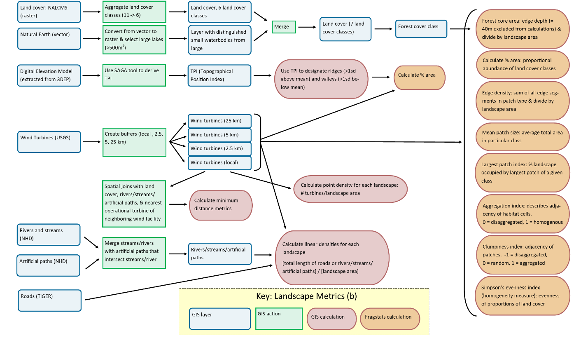

Figure 1. Workflow of independent variable calculations part of Peters et al. methods, visualized by M. Tango. (In Thesis paper, this is Figure 3b).

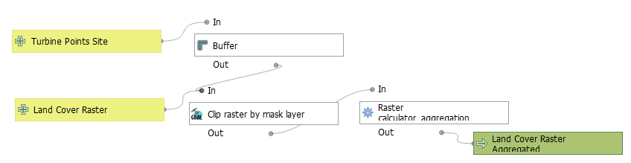

Figure 2. Preprocessing model. QGIS model: graphical modeler visualization. QGIS 3.16.4.

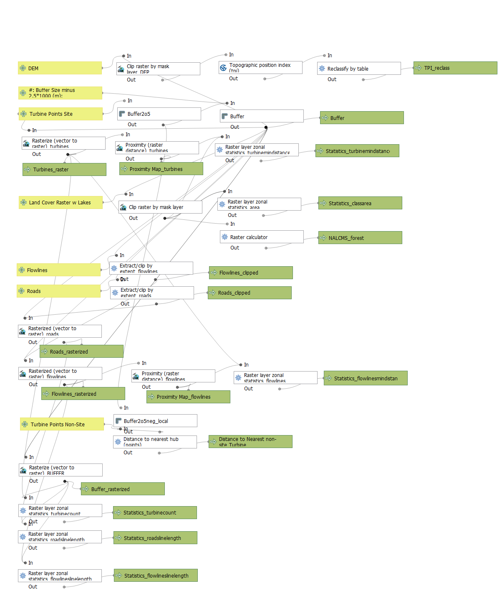

Figure 3. QGIS model: graphical modeler visualization. QGIS 3.16.4.

|  |  |
| --- | --- |
| **Landscape Parameter** | **Scale** |
| Mean Petch Area— Forest | 5 km |
| Mean Patch Area— Wetlands | 25 km |
| Edge Density— Wetlands | 25 km |
| Mean Patch Area— Open | Turbine Area |
| Mean Patch Area— Forest | Turbine Area |
| Minimum distance to turbine of nearby facility | Turbine Area |
| Linear density— Roads | Turbine Area |
| Mean Patch Area— Developed | 25 km |
| Mean Patch Area— Forest | 2.5 km |

Table 1. Transformed variables from Table 9 in Peters et al. (2020).

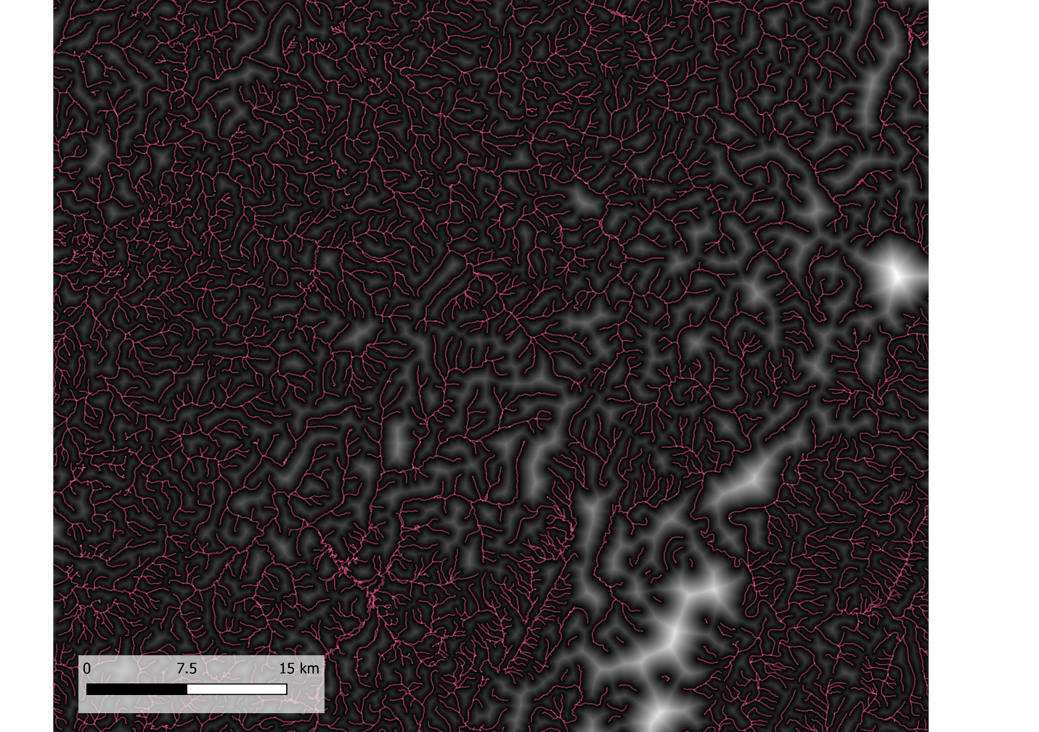

Figure 4. Proximity map (black to white) from flowlines (red). Each pixel in the proximity map raster shows distance from nearest flowline pixel.

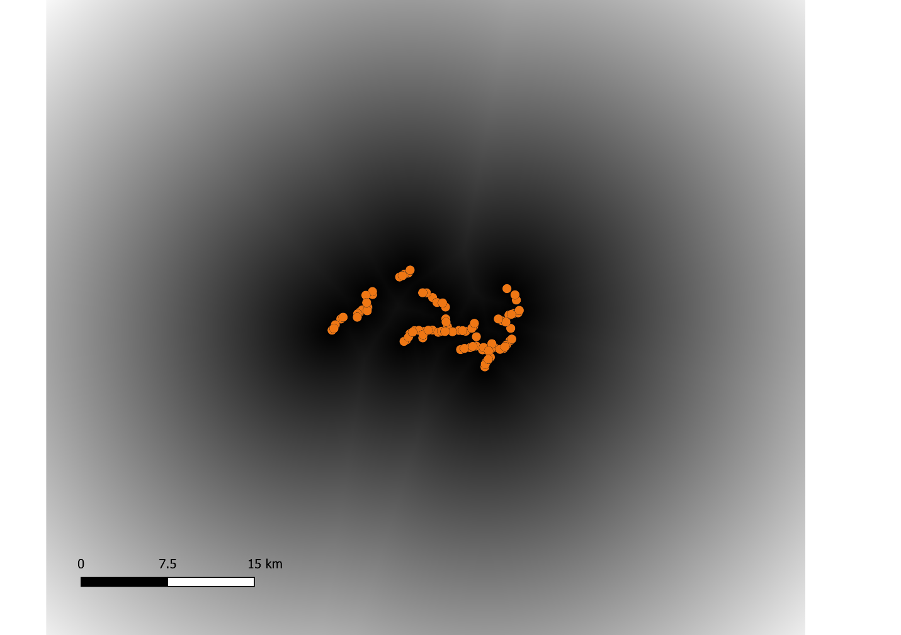

Figure 5. Proximity map from turbines. Each pixel in the proximity map raster shows distance from nearest turbine pixel.

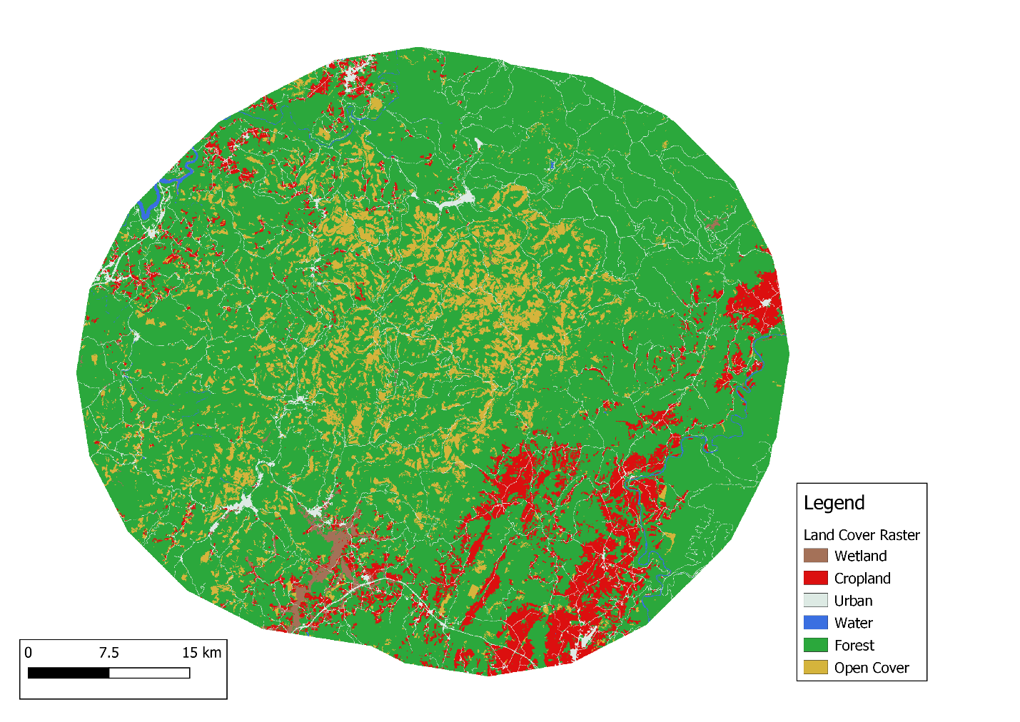

Figure 6. Land cover raster classes within a 25 km buffer of wind turbines at Beech Ridge wind site (aggregated from original NALCMS layer)

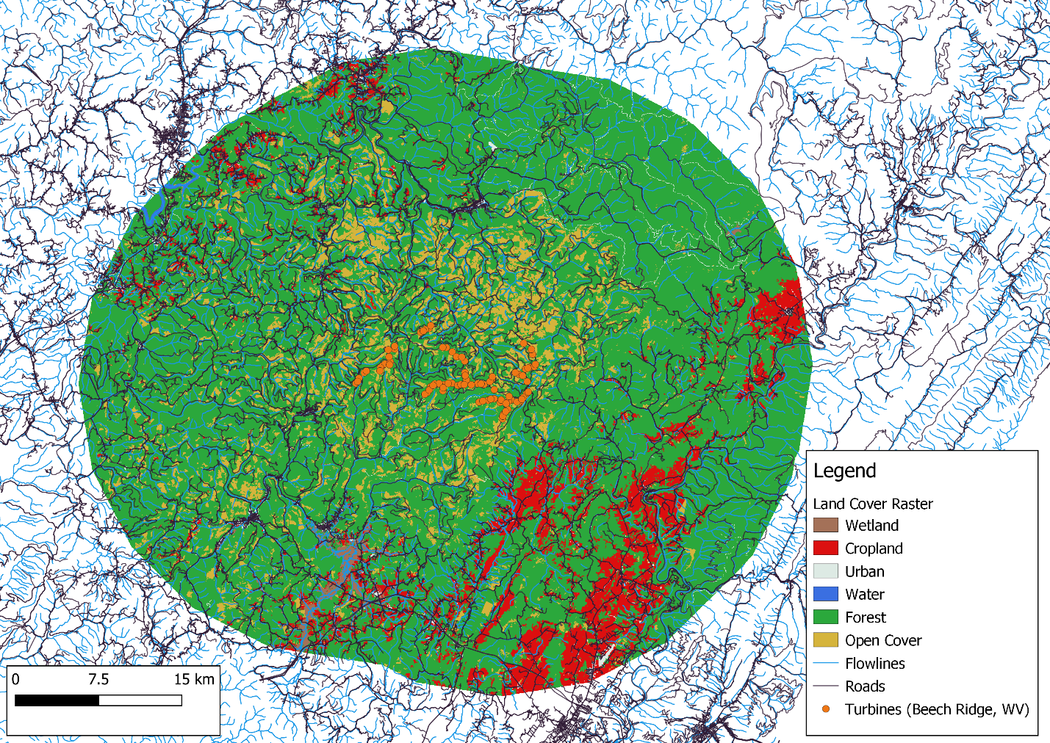

Figure 7. Land cover raster within a 25 km buffer of turbines at Beech Ridge wind site (WV), flowlines, and roads.

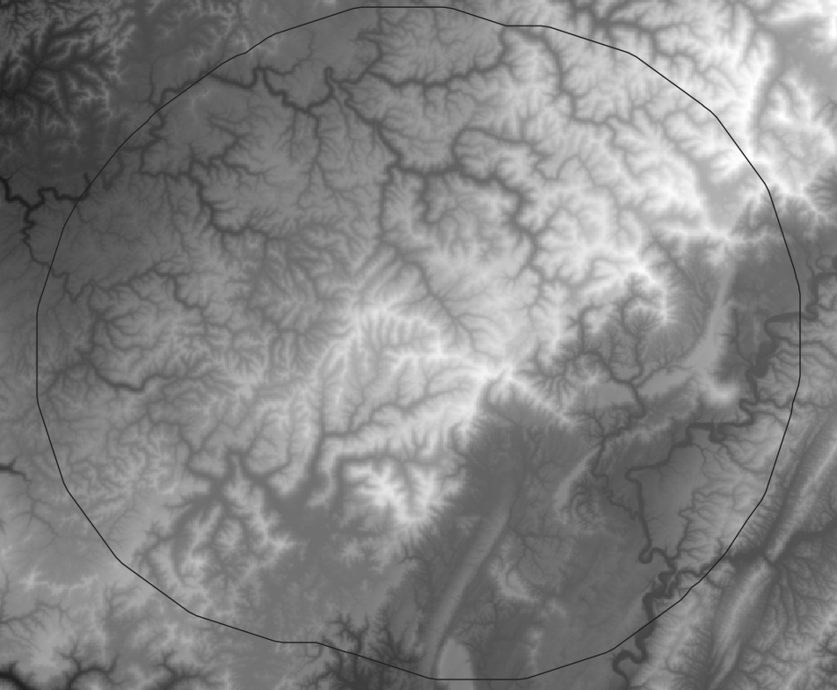

Figure 8. 3DEP layer with 25 km buffer from Beech Ridge, WV turbines

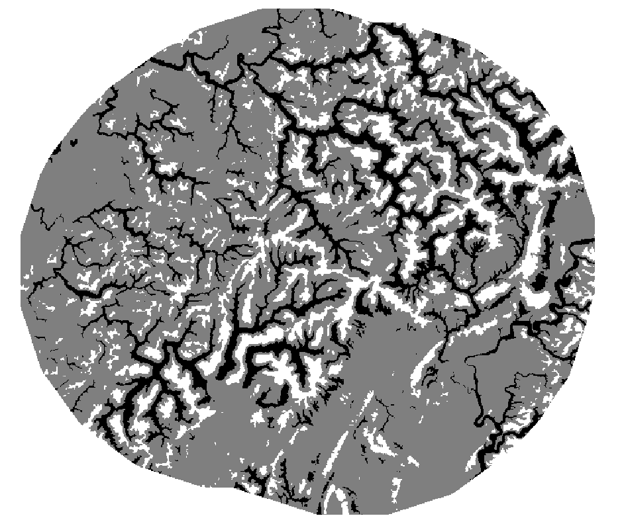

Figure 9. TPI reclass: ridges (white) and valleys (black); ridges >1SD from mean, valleys >-1SD from mean. Derived from 3DEP layer.

**Cited Sources**

Barton, K. 2020. MuMIn: Multi-Model Inference. R package version 1.43.17. https://CRAN.R-project.org/package=MuMIn

Calcagno, V. 2019. Glmulti: Model Selection and Multimodel Inference Made Easy. R package version 1.0.7.1. https://CRAN.R-project.org/package=glmulti.

Hesselbarth, M.H.K., M. Sciaini, K.A. With, K. Wiegand, & J. Nowosad. 2019. landscapemetrics: an open-source R tool to calculate landscape metrics. *Ecography* 42:1648-1657(ver. 0).

Liaw, A. & M. Wiener (2002). Classification and Regression by randomForest. *R News* 2(3), 18--22.

NHD. “Artificial Path.” https://nhd.usgs.gov/userGuide/Robohelpfiles/NHD_User_Guide/Feature_Catalog/Hydrography_Dataset/NHDFlowline/Artificial_Path.htm

R Core Team (2021). R: A language and environment for statistical computing. R Foundation for Statistical Computing, Vienna, Austria. https://www.R-project.org/.

RStudio Team (2020). RStudio: Integrated Development for R. RStudio, PBC, Boston, MA URL http://www.rstudio.com/.

USGS. “National Hydrography: National Hydrography Datase.” https://www.usgs.gov/core-science-systems/ngp/national-hydrography/national-hydrography-dataset?qt-science_support_page_related_con=0#qt-science_support_page_related_con

**Appendix 1**

NALCMS 2015 land classes are reaggregated based on the following values.

Layer source: cec.org/north-american-environmental-atlas/land-cover-30m-2015-landsat-and-rapideye/

* Value 14, Wetland, RGB 107 163 138;
  + Unchanged
* Value 15, Cropland, RGB 230 174 102;
  + Unchanged
* Value 17, Urban, RGB 220 33 38;
  + Unchanged
* Value 18, Water, RGB 76 112 163;
  + Unchanged (though lakes will be mosaicked in)
* Value 19, Snow and Ice, RGB 255 250 255.
  + Unchanged
* Value 20: Forest
  + Value 1, Temperate or sub-polar needleleaf forest, RGB 0 61 0;
  + Value 2, Sub-polar taiga needleleaf forest, RGB 148 156 112;
  + Value 3, Tropical or sub-tropical broadleaf evergreen forest, RGB 0 99 0;
  + Value 4, Tropical or sub-tropical broadleaf deciduous forest, RGB 30 171 5;
  + Value 5, Temperate or sub-polar broadleaf deciduous forest, RGB 20 140 61;
  + Value 6, Mixed forest, RGB 92 117 43;
* Value 21: Open Cover
  + Value 7, Tropical or sub-tropical shrubland, RGB 179 158 43;
  + Value 8, Temperate or sub-polar shrubland, RGB 179 138 51;
  + Value 9, Tropical or sub-tropical grassland, RGB 232 220 94;
  + Value 10, Temperate or sub-polar grassland, RGB 225 207 138;
  + Value 11, Sub-polar or polar shrubland-lichen-moss, RGB 156 117 84;
  + Value 12, Sub-polar or polar grassland-lichen-moss, RGB 186 212 143;
  + Value 13, Sub-polar or polar barren-lichen-moss, RGB 64 138 112;
  + Value 16, Barren lands, RGB 168 171 174;
* Value 23: Lakes
  + You add these yourself (see User Instructions section above)